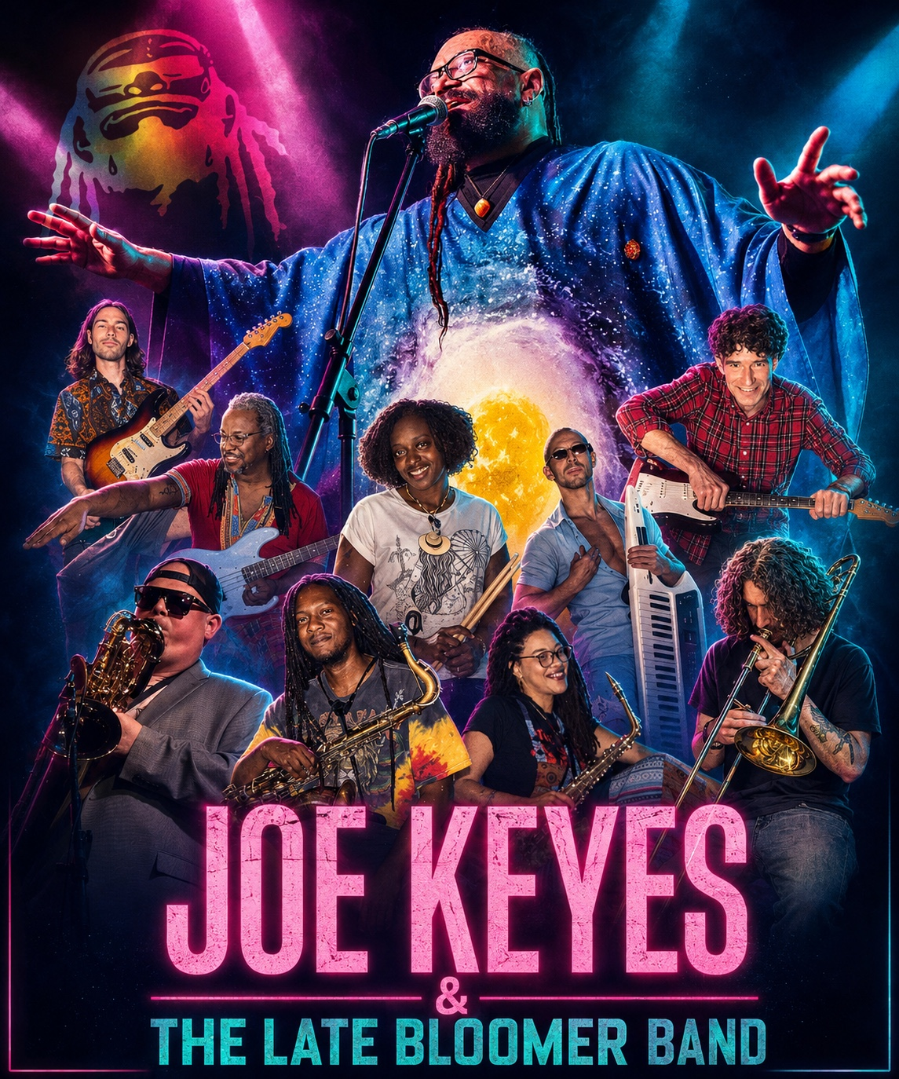
ELECTRONIC PRESS KIT
Prepared for Mark Sonder Productions Entertainment Agency • latebloomerband.com

THE LIVE EXPERIENCE
Joe Keyes is equal parts front man, poet and conductor. A Freehold, New Jersey native who found his true band and sound in 2009, Keyes built The Late Bloomer Band around musicians fluent in funk, R&B, soul, rock and jazz. Onstage, he does more than sing: he cues horn hits, opens space for solos, shapes crescendos and turns each set into a living conversation with the audience. The ensemble is intentionally multigenerational and multicultural, bringing together academically trained musicians whose varied backgrounds give the music both technical sophistication and lived-in soul.
The result is a large-format, groove-driven show that draws inspiration from Miles Davis, Gil Scott-Heron, Sun Ra and early Parliament-Funkadelic while refusing to behave like a nostalgia act. Original material, inventive musical mash-ups, spoken-word passages and improvisation make every performance distinct.

WHY BUYERS REMEMBER THE BAND
- Commanding frontman + bandleader: Keyes conducts the dynamics in real time, creating an event rather than a recital.
- Multigenerational + multicultural musicianship: academically trained players from different generations and cultural backgrounds create a sophisticated ensemble sound with the depth, spontaneity and perspective to connect across audiences.
- Flexible storytelling: sets can lean celebratory, dance-forward, socially conscious or tribute-based depending on the room.
- Visual impact: a full rhythm section and horn section give buyers the scale and excitement of a true live ensemble.
- Built for connection: humor, personal storytelling and crowd engagement give the performance a human center.

ARTISTIC TOUCHSTONES
Miles Davis • Gil Scott-Heron • Sun Ra • Parliament-Funkadelic • 1960s–1980s funk/soul culture • modern Baltimore/DC improvisational music

9-PIECE  core live ensemble | 2009  band formed | BALTIMORE / DC  home base

BOOKING CREDIBILITY

SELECTED STAGE & COLLABORATION HIGHLIGHTS
- Black Cat, Washington, D.C. — live performance, April 28, 2026
- CEC Community Education Center, Philadelphia — full-band concert, April 25, 2026
- Keystone Korner Baltimore — featured/encore performances
- Live appearances and collaborations featuring original Fishbone members Angelo “Dr. Madd Vibe” Moore and Norwood Fisher
- Stage-sharing credits publicly cited with Fishbone, George Clinton / Parliament-Funkadelic, Living Colour, DJ Logic and Ghost-Note
- NPR Tiny Desk submissions in 2025 and 2026, including “New Day” and “Loving Consciousness / Ethereal”

UPCOMING / CURRENTLY LISTED
DATE | ENGAGEMENT | MARKET
SEP 26, 2026 | 23rd Annual Pigtown Festival 2026 | Baltimore, MD
MAY 8, 2027 | Private Party | Harrisburg, PA
Scheduling note: dates above reflect public listings available at the time this EPK was prepared; confirm current availability directly with the artist.

REPERTOIRE & PROGRAM OPTIONS
- Original Late Bloomer Band repertoire
- Funk / soul / R&B / jazz / rock concert set
- Gil Scott-Heron tribute and message-music programming
- Extended improvisational festival or club set
- Curated corporate / cultural-event performance with emphasis on energy, storytelling and audience connection

WATCH • LISTEN • BOOK

FEATURED VIDEO
- Live at the Black Cat in DC — April 28, 2026
- “Loving Consciousness / Ethereal” — Tiny Desk Submission 2026
- “New Day” — Tiny Desk Submission 2025
- Band introductions / behind-the-scenes studio material

MUSIC
Album: Forever Is a Long Time (2017)
Selected tracks: “Ethereal,” “Hopin’ and Prayin’,” “In His Name” (feat. Angelo Moore), “Stinkbug in My Brownie,” “L.O.Y.D.”
2026 appearance: “America’s On Drugs” (feat. Joe Keyes and the Late Bloomer Band)
Music and streaming links on the official site

A STRONG FIT FOR MSP ENTERTAINMENT
Mark Sonder Productions books talent for corporate meetings, conventions, casinos, clubs, concert series, municipalities and special events. Joe Keyes & The Late Bloomer Band offers buyers a distinctive alternative to a standard cover band or passive background act: a scalable, high-energy ensemble with a recognizable artistic point of view, strong audience interaction and programming that can work in both entertainment-first and culture-forward settings.
BOOKING POSITIONING
“A horn-driven funk, soul and jazz experience led by a true frontman-conductor — built for audiences who want to feel the show, not just hear it.”

OFFICIAL LINKS
Website: https://latebloomerband.com/
YouTube: https://www.youtube.com/@joekeyes7038/videos
Bandsintown / live dates: https://www.bandsintown.com/a/1196531-joe-keyes-
Facebook: https://www.facebook.com/thelatebloomerband
JOE KEYES & THE LATE BLOOMER BAND
www.latebloomerband.com

